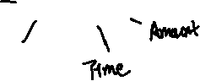

Item



Bidder

Seller

Auction

Bid

Category